Batsheva Serota
Dr. Alli Hammond
English 112
15 March 2011
A Poetic Picture of ‘Sexy’
The following is a series of found poems, each accompanied by a wordle, where the text from the poem was derived from. The purpose of found poetry is to “refashion” a text, picking out relevant words and phrases, and rearranging them to form a poem (Poets). In this case, the poems were each meant to embody a different definition and take on the word ‘sexy,’ reflecting the message of their individual sources. The purpose of each wordle is to compliment its respective poem, not only providing a visual representation of the poem, but also pointing out key words in a more striking way. The final wordle paired with its found poem includes all of the above sources combined; the purpose of the final poem is to emphasize the most important topics surrounding the meaning of the word ‘sexy’ as well as to reflect my own opinion on the topic.

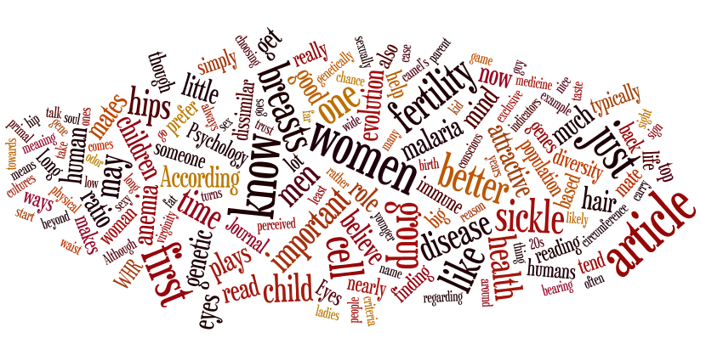

virginity plays:
genetic first—
important cell
believes criteria.

attractive indicators
immune to reason:

just mate.

cultures

ways

know breasts

[…beyond physical].

evolution of women

(always sex).

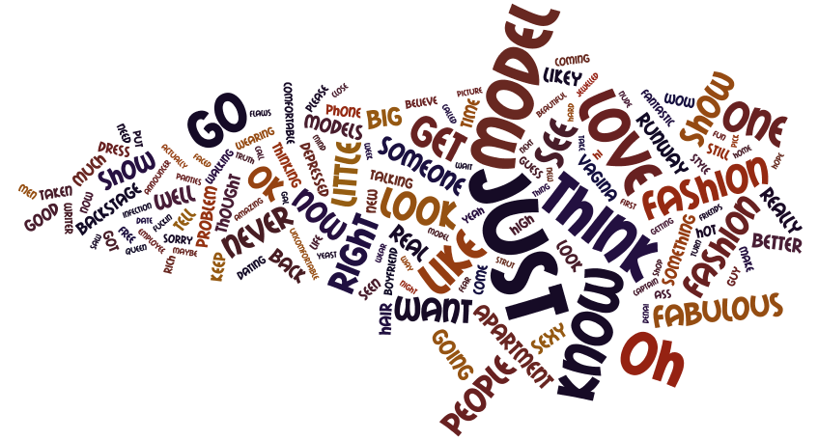
get someone
to look:

just think fashion.

want boyfriend?
vagina love,
never know.

comfortable model’s
sexy strut
getting ass.

wow.

oh.

fabulous.

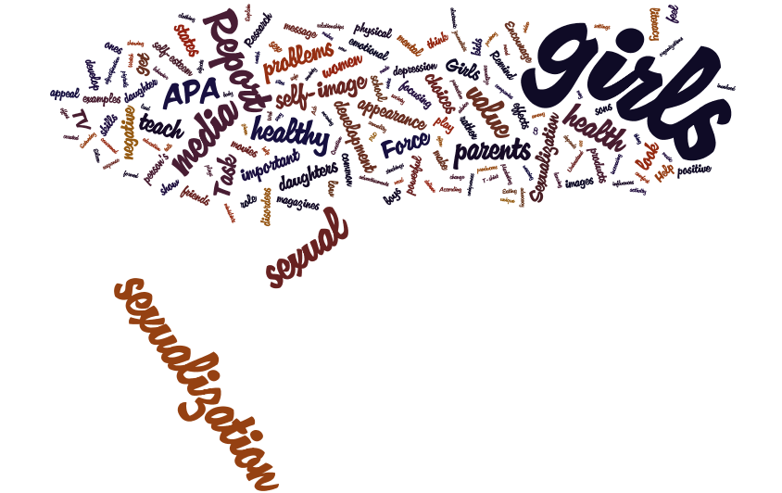
media problems
focusing choices,
teach negative.

sexual task—
a positive value.

help girls:
appearance
self- image
health
development

self- esteem?
examples?

…in the movies.
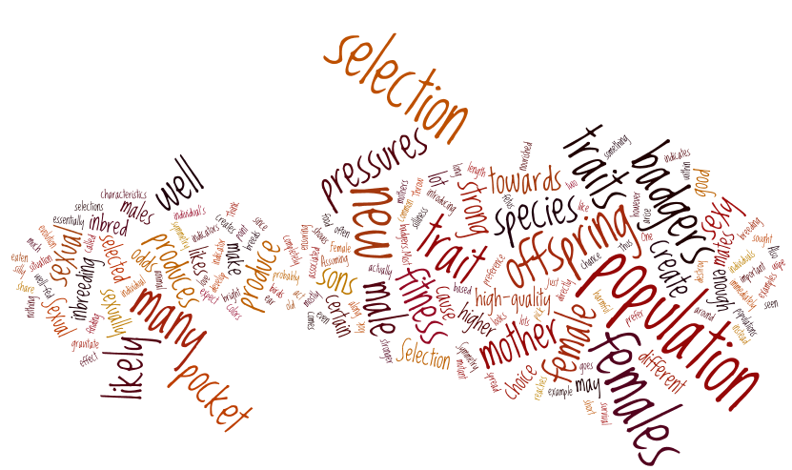
a high- quality cause

creates

selection pressures.

enough mates,
female choice
(male selection).

a strong trait?
create new sons.

selection

causes

fitness:

sexy badgers.

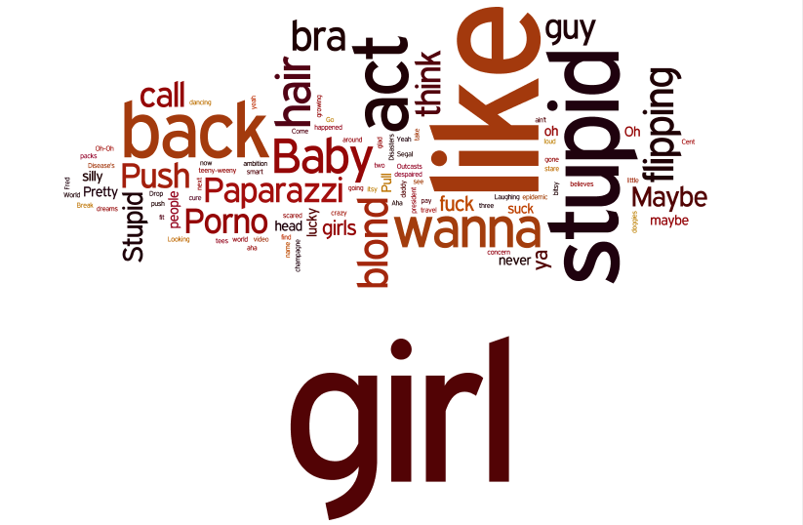

silly,

pretty,

hair- flipping

stupid girls.

call back?

maybe.

(lucky you don’t think.)

paparazzi porno—

she’s just a baby.

wanna fuck?

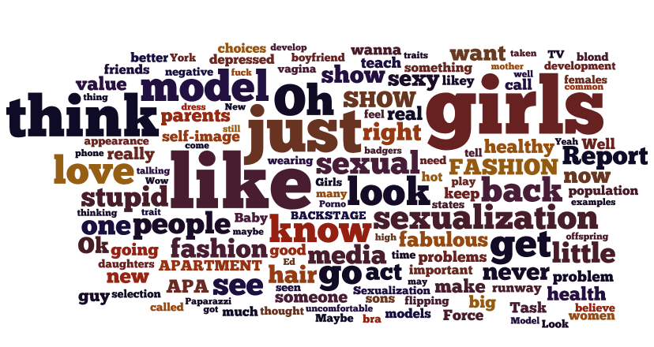
think model
(just like girls).

media—
go.

runway force
loves stupid people.
fashion report,
healthy now.

got much thought?
never.

blonde development,
better vagina.

wanna teach something?
show sexy.
new guy selection.

depressed choices?

believe women.

fuck negative.

value a better thing.

Works Cited
Busch, Jack. "The Science of Sexy: How Evolution Drives Our Lust." Primer Magazine.
N.p., 2011. Web. 4 Mar. 2011. <http://www.primermagazine.com/2009/learn/the-
science-of-sexy-how-evolution-drives-our-lust>.
Gurian, Anita. "The Sexualization of Girls and Mental Health Problems: Is There a
Connection?." NYU Child Study Center. Langone Medical Center, n.d. Web. 4 Mar. 2011. <http://www.aboutourkids.org/articles/sexualization_girls_me ntal_health_problem s_there_connection>.
"Pink Lyrics: "Stupid Girls"." AZ Lyrics. N.p., 2011. Web. 5 Mar. 2011.
< http://www.azlyrics.com/lyrics/pink/stupidgirls.html>.
"Poetic Form: Found Poem." Poets. Academy of American Poets, 2011. Web. 6 Mar.
2011. <http://www.poets.org/viewmedia.php/prmMID/5780>.
"Sex and the City Transcripts: The Real Me." The Television Transcripts Database. Ed.
Zaragoza. N.p., 3 June 2001. Web. 4 Mar. 2011. <http://www.tvtdb.com/sexandth ecity/transcripts/4x02.php>.
"Sexual Selection." EvoEdu: Evolution Education. Ed. Tristan Zimmerman. N.p., 2009.
Web. 4 Mar. 2011. <http://www.evoedu.com/sexualselection.html>.
Wordle. Ed. Jonathan Feinberg. N.p., 2009. Web. 6 Mar. 2011.
<http://www.wordle.net/>.

