Explore the wonders of Buddhism through a series of paintings and poems!
Thursday, May 5, 2011
708 Swift Hall, 6:00pm-7:30pm
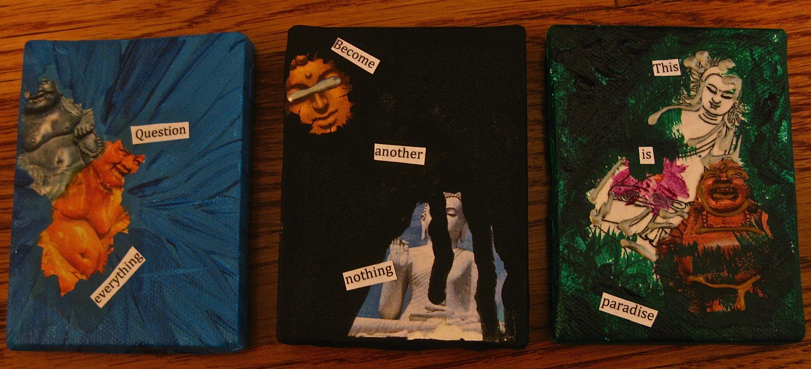
The artwork presented reflects what I learned about the teachings of Buddhism throughout the course of my experiential learning project. Join me to view the paintings and poems that I created for my dissemination; refreshments provided. I hope to see you all there!
-Sheva Serota

